Clement Mabelebele
ST10507632
POE

Response

The feedback that was given to me on part 1 was that: “My html needed more content and everything else was functional and everything was working accordingly”

So, from the feedback received more content was increased by adding more content in the website to make it suitable for users new backgrounds were added the about us and other pages were filled with content that benefited the description of the organisation icons were added many other paragraph tags were added and brought more depth to the website as requested improving the “skeleton” to better prepare the insertion of the CSS and the JavaScript that were about to pull on part 2 and three page linking comments were verified many established improvements that part one everything was else was structured accordingly more reliability and compatibility for better insertion of other required coding languages everything required was implemented according to what the lecturer instructed

AFTER PIC

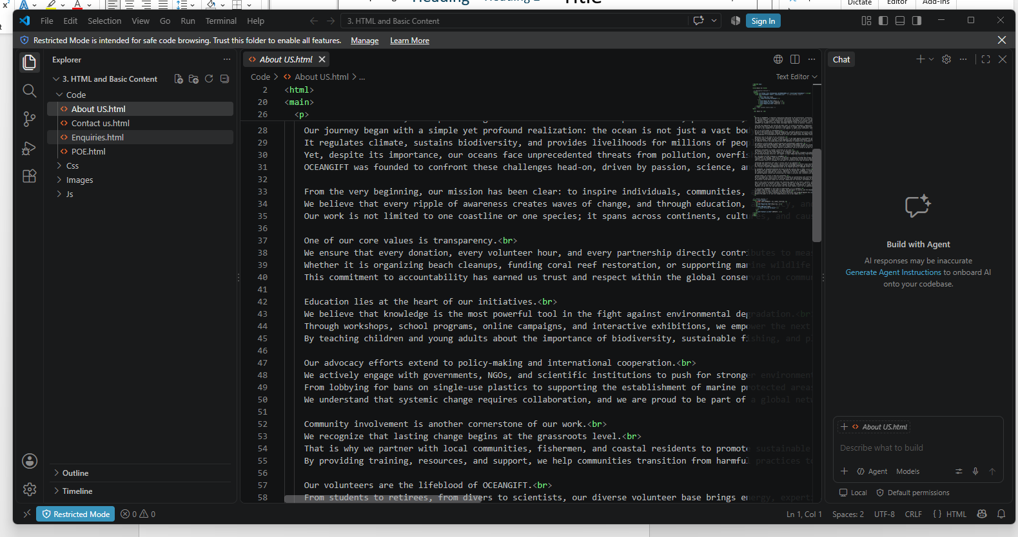
Figure1:

Before the about us page had no info the paragraph tags were empty

AFTER PIC

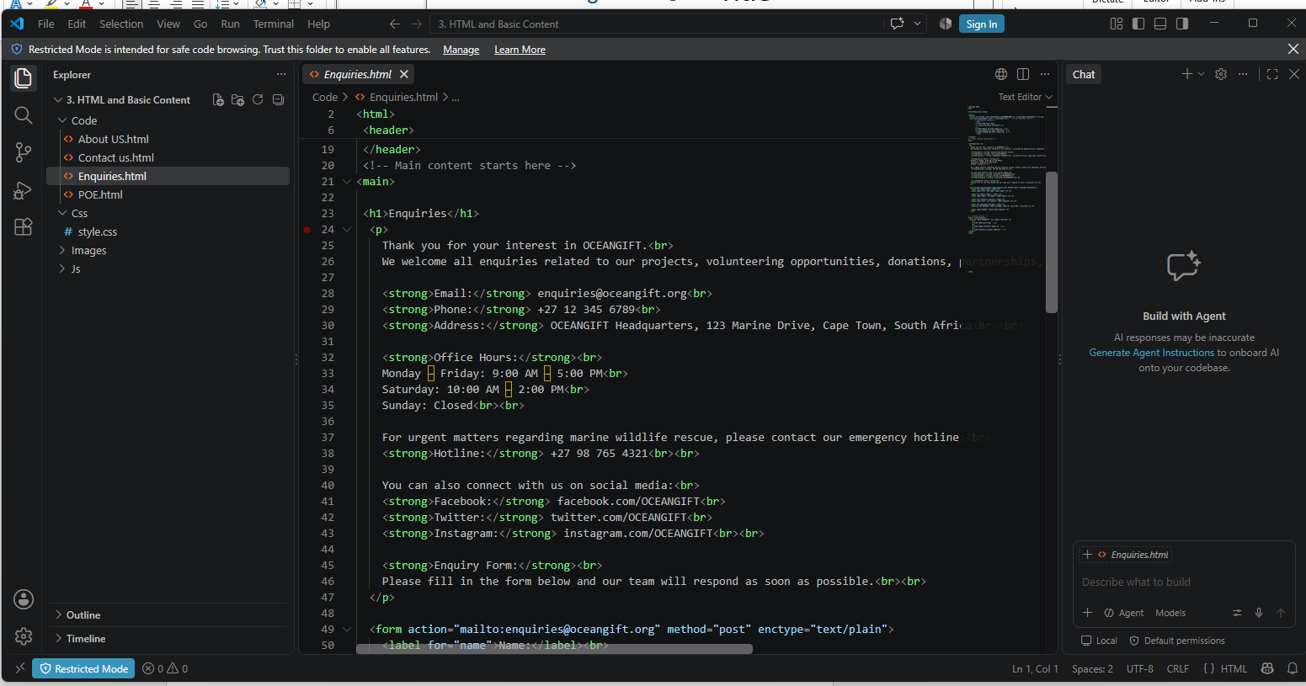
Figure 2

Same with the about us page the enquiries page has been added with more content as requested making the “skeleton” html more compatible and customisable for CSS

AFTER PIC

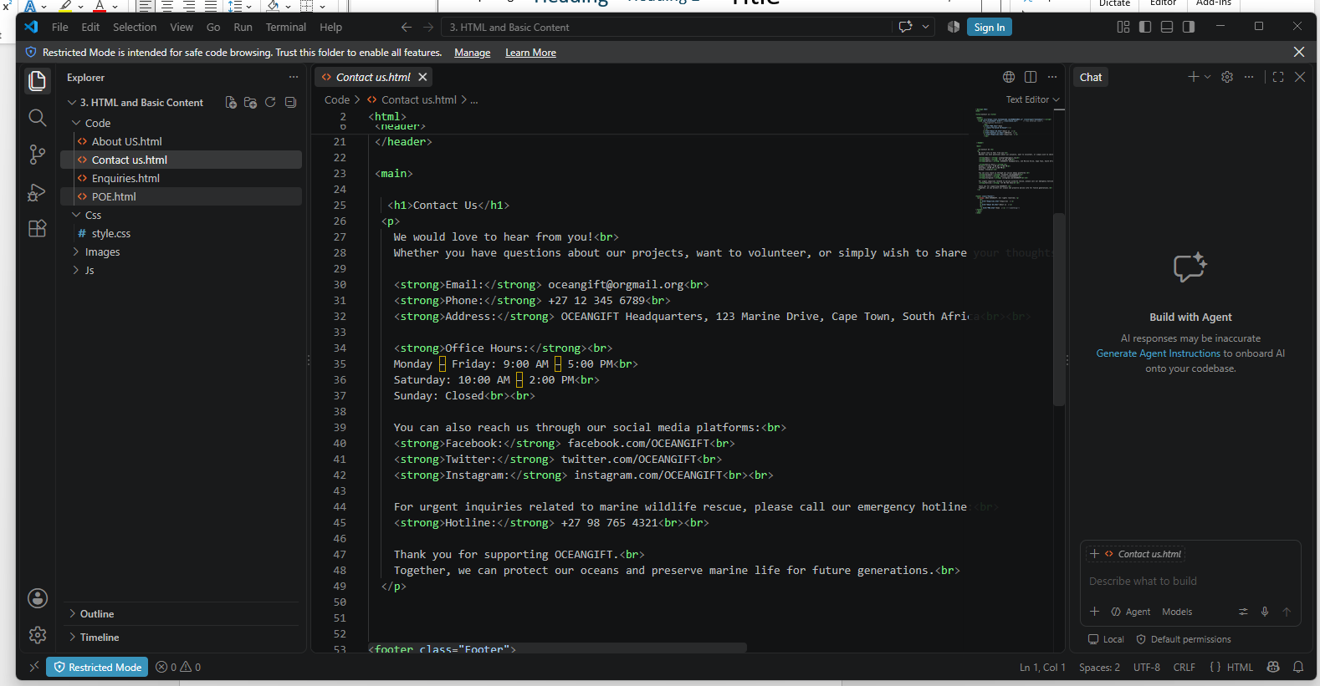
Figure 3
Lastly but not least the Contact us page has been greatly improved with new content added

